

MARMARA UNIVERSITY
FACULTY OF ENGINEERING

PHYS 1104.14
PHYSICS LABORATORY II
—————————————————————————————————————————
Capasitor Charge & Discharge
—————————————————————————————————————————
Section: 14

Group: 12

Instructure: Capasitor Charge & Discharge Date: 07/05/2025 8:59 am

 | Department | Student ID Number | Name & Surname
1 | Computer Engineering | 150123046 | Cihangir YAMAN
2 | Computer Engineering | 150123073 | Emir GÜDER
3 | Computer Engineering | 150123034 | Samet KURUŞ

1. Table of Contents

1. Table of Contents 2
2. Purpose 3
3. Theory 3
4. Experimental Setup 3
4.1. List Of Materials 4
4.2. Procedure 4
5. Calculations and Results 5
Part 1 5
6. Discussion and Conclusion 8
7. References 9
8. Appendix 10
Experiment Sheet 10

Purpose :
The main objective of this experiment is to investigate the charging and discharging processes of a capacitor in an RC circuit and to observe the effects of parameters such as capacitance (C), resistance (R) and source voltage (V) on these processes. The specific objectives of the experiment are as follows:

1.)Observing Charging Behavior: In a series circuit consisting of a resistor and a capacitor, observe how the voltage across the capacitor and the current flowing through the circuit change over time and record these data.
2)Studying the Effect of Parameter Variations:
a)Capacitance (C): To compare results using different capacitors (1000 µF and 2000 µF).
b)Resistance (R): To study the response of the circuit with different resistance values (10 kΩ and 20 kΩ)
c) Voltage (V): Analyze the charging behavior with different source voltages (5 V and 10 V).
3) Determining Time Constants: Calculate the theoretical time constant value for each circuit configuration; obtain the experimental time constant from the slope of the ln(I) time plot.
4) Performing Error Analysis: Calculate the differences between theoretical and experimental in terms of percentage error, taking into account the tolerances and measurement errors of the resistors and capacitors used.

Theory:
Capacitors are passive circuit elements that can store electric charges. In its simplest form, a capacitor consists of two conductive plates with an insulating material (dielectric) between them. When a voltage source is connected between these plates, one plate is charged positively and the other plate is charged negatively, thus creating an electric field between them. The amount of charge is directly proportional to the potential difference between the plates and this ratio is defined as capacitance:

C = Q/V

Here are capacitance (in Farads), charge (in Coulombs) and voltage. Capacitors are used for short-term storage of electrical energy, filtering or in timing circuits

The RC circuit studied in this experiment is a basic circuit in which a capacitor and a resistor are connected in series. When a constant direct current (DC) voltage is applied to such a circuit, the capacitor charges over time. Initially the capacitor is empty so maximum current flows through the circuit, over time as the capacitor charges the current flowing through the circuit decreases and the voltage across the capacitor increases. The charging process is described by the following equation:
Vc(t) = Vs(1- e^(-t/RC))

Where:

Vc(t) : capacitor voltage at time t

Vs: source voltage

R : resistance (ohm)

C : capacitance (farad)

T : time (seconds)

When the capacitor is fully charged, the voltage across the capacitor is equal to the source voltage and no current flows through the circuit.

Similarly, when a charged capacitor is discharged through a resistor, the voltage across the capacitor and the current through the circuit decreases exponentially.

I(t) = -(Vs/R) * e^(-t/RC)

Experimental Setup
List of material:
1. Board x1
2. DC Voltage Source (0 – 30 V range) x1
3. Digital Multimeter x2
4. On-off switch x1
5. 1000 µF Capacitor x2
6. Connection cables
7. 10 kΩ Resistor x1

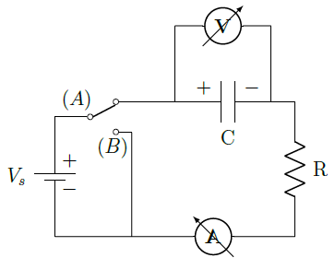

Figure 1: Circuit diagram
The experimental setup is shown in Figure 1. The internal resistance of the digital multimeter and the setting time can be ignored. R is a protective resistor that limits the current when discharging the capacitor when set to Switch B
In this experiment, the voltage across the capacitor and the current through the circuit are recorded as a function of time for different values of capacitance and source voltage.

Calculations

Data Table
Table 2. Recorded values of voltage and current of Part I, Part II and Part IV
Part I.  R₁=10 kΩ, C₁=1000 μF |  |  | Part II.  R₂=20 kΩ, C₁=1000 μF |  |  | Part IV.  R₂=20 kΩ, C₂=2000 μF
Time (s) | $I$ (mA) | $V_{c}$ (V) | Time (s) | $I$ (mA) | $V_{c}$ (V) | Time (s) | $I$ (mA) | $V_{c}$ (V)
1 | 0.99 | 0.50 | 1 | 0.45 | 0.13 | 5 | 2.26 | 0.03
2 | 0.95 | 0.84 | 2 | 0.42 | 0.76 | 9 | 2.06 | 0.50
3 | 0.84 | 1.80 | 3 | 0.40 | 1.21 | 13 | 1.85 | 0.95
4 | 0.77 | 2.65 | 4 | 0.39 | 1.35 | 17 | 1.68 | 1.32
5 | 0.70 | 3.41 | 7 | 0.36 | 2.29 | 23 | 1.48 | 1.78
7 | 0.57 | 4.71 | 10 | 0.30 | 3.46 | 29 | 1.27 | 2.22
9 | 0.44 | 5.74 | 13 | 0.26 | 4.35 | 37 | 1.08 | 2.63
11 | 0.36 | 6.57 | 17 | 0.21 | 5.27 | 45 | 0.86 | 3.11
13 | 0.29 | 7.23 | 21 | 0.18 | 6.04 | 55 | 0.69 | 3.50
15 | 0.22 | 7.76 | 26 | 0.14 | 6.89 | 65 | 0.55 | 3.78
18 | 0.17 | 8.31 | 32 | 0.10 | 7.70 | 78 | 0.40 | 4.12
21 | 0.12 | 8.81 | 38 | 0.08 | 8.21 | 91 | 0.30 | 4.34
24 | 0.09 | 9.09 | 45 | 0.06 | 8.69 | 108 | 0.20 | 4.55
28 | 0.06 | 9.41 | 52 | 0.04 | 9.06 | 129 | 0.13 | 4.72
33 | 0.03 | 9.64 | 60 | 0.03 | 9.33 | 154 | 0.07 | 4.83
38 | 0.02 | 9.77 | 68 | 0.02 | 9.53 | 185 | 0.04 | 4.91
44 | 0.01 | 9.86 | 78 | 0.01 | 9.70 | 215 | 0.02 | 4.95
51 | 0.01 | 9.91 | 88 | 0.01 | 9.79 | 250 | 0.02 | 4.96
58 | 0.00 | 9.94 | 100 | 0.00 | 9.86 | 295 | 0.01 | 4.98
60 | 0.00 | 9.95 | 111 | 0.00 | 9.90 | 319 | 0.00 | 4.99

Table 3., Charge and discharge
- Charge |  |  | - Discharge
Time (s) | $I$ (mA) | $V_{c}$ (V) | Time (s) | $I$ (mA) | $V_{c}$ (V)
1 | 0.45 | 0.17 | 1 | 0.44 | 9.67
6 | 0.38 | 1.31 | 6 | 0.38 | 8.68
11 | 0.35 | 2.37 | 14 | 0.32 | 6.98
16 | 0.31 | 3.24 | 22 | 0.26 | 5.79
23 | 0.26 | 4.15 | 32 | 0.23 | 4.62
30 | 0.22 | 5.06 | 42 | 0.16 | 3.67
39 | 0.18 | 6.02 | 55 | 0.12 | 2.69
48 | 0.15 | 6.75 | 70 | 0.08 | 1.88
60 | 0.11 | 7.54 | 95 | 0.06 | 1.32
72 | 0.08 | 8.14 | 100 | 0.04 | 0.92
87 | 0.06 | 8.67 | 115 | 0.03 | 0.66
102 | 0.04 | 9.04 | 134 | 0.02 | 0.43
120 | 0.03 | 9.35 | 154 | 0.01 | 0.27
140 | 0.02 | 9.58 | 187 | 0.00 | 0.13
170 | 0.01 | 9.76 | 204 | 0.00 | 0.09
201 | 0.00 | 9.86 | 214 | 0.00 | 0.07

Table 4. % error of time constants
Part | Value of Voltage, Resistance and Capacitor |  |  | Time constant (τ)
Part |  |  |  | Theoretical | Experimental | % error
1 | V₁:10 | R₁:10 | C₁:1000 | 10s | 5.40s | 45.01%
2 | V₁:10 | R₂:10 | C₁:1000 | 20s | 10.74s | 46.30%
3.A | V₁:10 | R₂:20 | C₂:2000 | 40s | 17.19s | 57.02%
3.B | V₁:10 | R₂:20 | C₂:2000 | 40s | 19.41s | 51.47%
4 | V₂:5 | R₂:20 | C₂:2000 | 40s | 34.07s | 14.84%

Curves of Best Fit

To better understand behaviors of the charging and discharging capacitors in our experiment, we applied curve fitting to the experimental current and voltage data.

Capacitor Charging
The capacitors showed a nonlinear current&voltage-time relationship. When the chart is created with data gained in experiment, the line formed a curve that deviated clearly from a straight line. As shown in the formulas below (1)(2) the Current and Voltage are non-linear according to time.

$I\left(t\right)=$ $\frac{V_{s}}{R}$ $e^{-\frac{t}{RC}}$ (1)
$V_{c}=V_{s}(1-e^{-\frac{t}{RC}})$ (2)

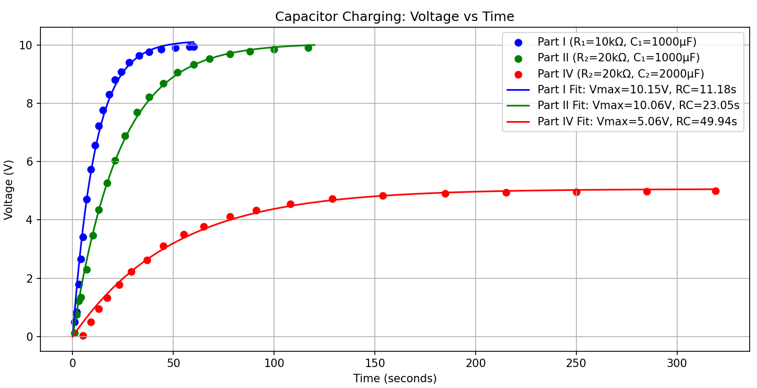
Figure 1: Part I, Part II, Part IV Charging Curves Voltage-Time

As shown in the Figure 1 above, voltage is directly proportional to time when charging capacitors. Also, as shown in the Figure 2 below, current is inversely proportional to time when charging capacitors.

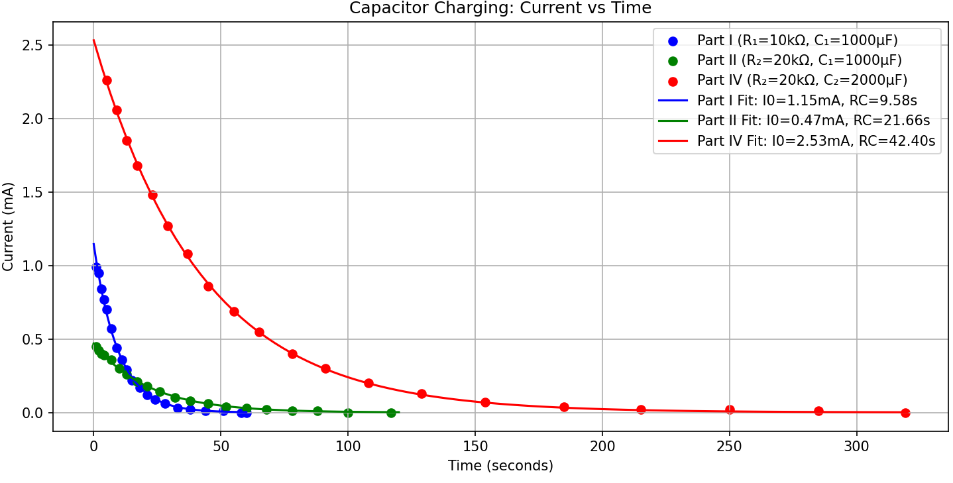
Figure 2: Part I, Part II, Part IV Charging Curves Current-Time

Capacitor Current Charging and Discharging
The capacitors showed a nonlinear current-time relationship not only when charging also when discharging. When the chart is created with data gained in experiment, the line formed a curve that deviated clearly from a straight line. As shown in the formulas above(1)(2) the current is non-linear according to time when charging and discharging.

We can clearly see in the Figure 3 and Figure 4 above, current is inversely proportional to time both when charging and discharging capacitors.

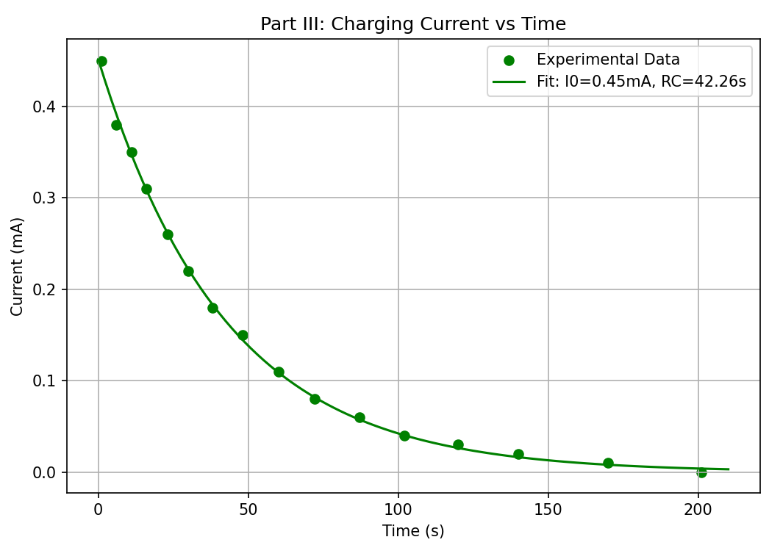
Figure 3: Part III Charging Curve Current-Time

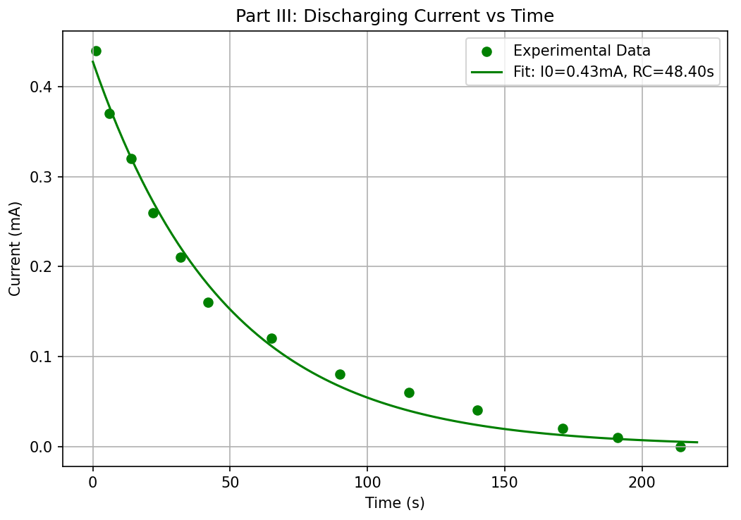
Figure 4: Part III Discharging Curve Current-Time

